将代码贴在各题下面，将运行结果贴在各题下面。
- 课本P191 第1题。同时要求：在书名、描述中，输入信息后，点击OK按钮，显示书名、描述信息；点击Cancel按钮，关闭应用程序。

import java.awt.BorderLayout;
import java.awt.EventQueue;

import javax.swing.JFrame;
import javax.swing.JPanel;
import javax.swing.border.EmptyBorder;
import javax.swing.JLabel;
import javax.swing.JOptionPane;
import javax.swing.JTextField;
import javax.swing.JEditorPane;

import java.awt.Scrollbar;
import java.awt.TextArea;
import java.awt.FlowLayout;

import javax.swing.JButton;

import java.awt.event.ActionListener;
import java.awt.event.ActionEvent;

public class Swing_first extends JFrame {

private JPanel contentPane;
private JTextField textField;
TextArea textArea;

/**
* Launch the application.
*/
public static void main(String[] args) {
EventQueue.invokeLater(new Runnable() {
public void run() {
try {
Swing_first frame = new Swing_first();
frame.setVisible(true);
} catch (Exception e) {
e.printStackTrace();
}
}
});
}

/**
* Create the frame.
*/
public Swing_first() {
super("窗体");
setDefaultCloseOperation(JFrame.EXIT_ON_CLOSE);
setBounds(100, 100, 520, 518);
contentPane = new JPanel();
contentPane.setBorder(new EmptyBorder(5, 5, 5, 5));
setContentPane(contentPane);
contentPane.setLayout(null);

JPanel panel = new JPanel();
panel.setBounds(14, 32, 474, 91);
contentPane.add(panel);
panel.setLayout(null);

JLabel lblNewLabel = new JLabel("请输入书籍的名称:");
lblNewLabel.setBounds(24, 13, 158, 18);
panel.add(lblNewLabel);

textField = new JTextField();
textField.setBounds(24, 44, 443, 24);
panel.add(textField);
textField.setColumns(10);

JPanel panel_1 = new JPanel();
panel_1.setBounds(14, 136, 474, 249);
contentPane.add(panel_1);
panel_1.setLayout(null);

JLabel lblNewLabel_1 = new JLabel("请输入书籍的详细描述:");
lblNewLabel_1.setBounds(27, 13, 166, 18);
panel_1.add(lblNewLabel_1);

textArea = new TextArea();
textArea.setBounds(26, 37, 438, 190);
panel_1.add(textArea);

JPanel panel_2 = new JPanel();
panel_2.setBounds(14, 384, 474, 53);
contentPane.add(panel_2);
panel_2.setLayout(new FlowLayout(FlowLayout.CENTER, 5, 5));

JButton btnNewButton = new JButton(" Ok ");
btnNewButton.addActionListener(new ActionListener() {
public void actionPerformed(ActionEvent e) {
String message1 = textField.getText();
String message2 = textArea.getText();
JOptionPane.showMessageDialog(null, "书籍名称:"+message1 + "\n书籍描述:" + message2, "输出 ", 1);

}
});
panel_2.add(btnNewButton);

JButton btnNewButton_1 = new JButton(" Cancer ");
btnNewButton_1.addActionListener(new ActionListener() {
public void actionPerformed(ActionEvent e) {
}
});
panel_2.add(btnNewButton_1);
}
截图：
}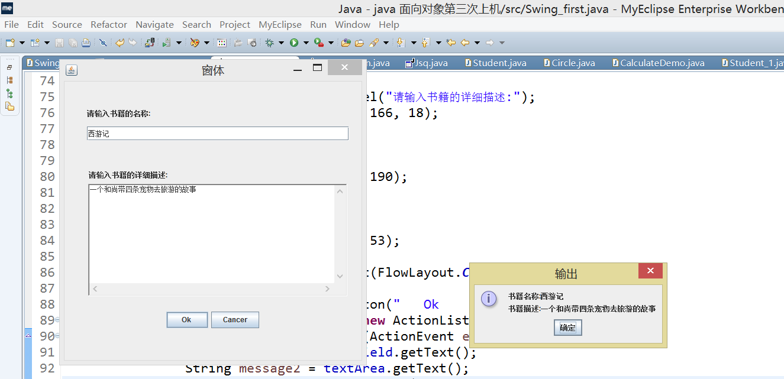

- 课本P192 第8题。
import java.awt.BorderLayout;
import java.awt.EventQueue;

import javax.swing.JFrame;
import javax.swing.JPanel;
import javax.swing.border.EmptyBorder;
import javax.swing.JTextField;
import java.awt.GridLayout;
import javax.swing.JButton;
import java.awt.FlowLayout;
import javax.swing.JLabel;
import java.awt.event.ActionListener;
import java.awt.event.ActionEvent;
import javax.swing.JRadioButton;

public class RationButton extends JFrame {

private JPanel contentPane;
private JPanel panel_2;
private JLabel lblNewLabel;

/**
* Launch the application.
*/
public static void main(String[] args) {
EventQueue.invokeLater(new Runnable() {
public void run() {
try {
RationButton frame = new RationButton();
frame.setVisible(true);
} catch (Exception e) {
e.printStackTrace();
}
}
});
}

/**
* Create the frame.
*/
public RationButton() {
super("RadioButton");
setDefaultCloseOperation(JFrame.EXIT_ON_CLOSE);
setBounds(100, 100, 452, 225);
contentPane = new JPanel();
contentPane.setBorder(new EmptyBorder(5, 5, 5, 5));
setContentPane(contentPane);
contentPane.setLayout(null);

JPanel panel = new JPanel();
panel.setBounds(14, 13, 404, 75);
contentPane.add(panel);
panel.setLayout(null);

panel_2 = new JPanel();
panel_2.setBounds(30, 27, 348, 24);
panel.add(panel_2);
panel_2.setLayout(new FlowLayout(FlowLayout.CENTER, 5, 5));

lblNewLabel = new JLabel("You Choosed : SOUTH");
panel_2.add(lblNewLabel);

JPanel panel_1 = new JPanel();
panel_1.setBounds(14, 96, 404, 34);
contentPane.add(panel_1);
panel_1.setLayout(new GridLayout(1, 4, 10, 50));

JRadioButton rdbtnNewRadioButton_1 = new JRadioButton("EAST");
rdbtnNewRadioButton_1.addActionListener(new ActionListener() {
public void actionPerformed(ActionEvent e) {
lblNewLabel.setText("You Choosed : EAST");
}
});
panel_1.add(rdbtnNewRadioButton_1);

JRadioButton rdbtnNewRadioButton_3 = new JRadioButton("SOUTH");
rdbtnNewRadioButton_3.addActionListener(new ActionListener() {
public void actionPerformed(ActionEvent e) {
lblNewLabel.setText("You Choosed : SOUTH");
}
});
panel_1.add(rdbtnNewRadioButton_3);

JRadioButton rdbtnNewRadioButton_2 = new JRadioButton("WEST");
rdbtnNewRadioButton_2.addActionListener(new ActionListener() {
public void actionPerformed(ActionEvent e) {
lblNewLabel.setText("You Choosed : WEST");
}
});
panel_1.add(rdbtnNewRadioButton_2);

JRadioButton rdbtnNewRadioButton = new JRadioButton("NORTH");
rdbtnNewRadioButton.addActionListener(new ActionListener() {
public void actionPerformed(ActionEvent e) {
lblNewLabel.setText("You Choosed : NORTH");
}
});
panel_1.add(rdbtnNewRadioButton);
}
}

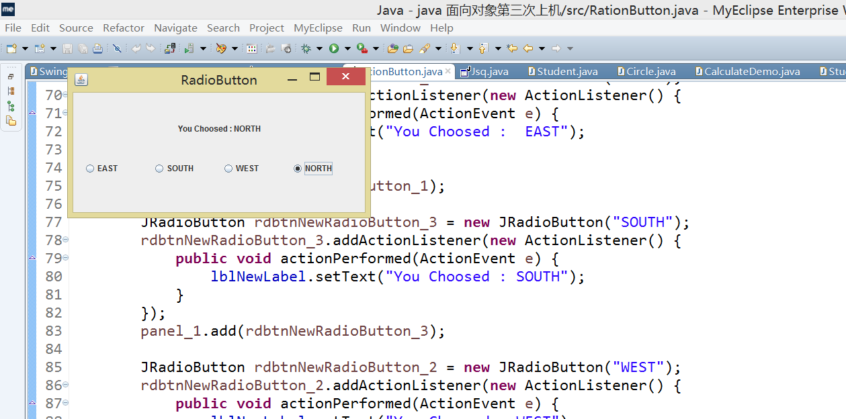
- 课本P192 第9题。要求：2个文本框，中间一个符号列表（+、-、*、/），一个 = 按钮，最后一个Label，显示计算结果。点击 = 按钮时，就开始计算并显示结果（或其他形式的计算器功能均可）。
import java.awt.EventQueue;

import javax.swing.JFrame;
import javax.swing.JPanel;
import javax.swing.border.EmptyBorder;

import java.awt.GridLayout;

import javax.swing.JButton;

import java.awt.event.ActionListener;
import java.awt.event.ActionEvent;

import javax.swing.JTextField;

import org.omg.CORBA.PUBLIC_MEMBER;

public class Jsq extends JFrame {

private JPanel contentPane;
private JTextField textField;
int a,b,d;
int flag=0;
/**
* Launch the application.
*/
public static void main(String[] args) {
EventQueue.invokeLater(new Runnable() {
public void run() {
try {
Jsq frame = new Jsq();
frame.setVisible(true);
} catch (Exception e) {
e.printStackTrace();
}
}
});
}

/**
* Create the frame.
*/
public Jsq() {

setDefaultCloseOperation(JFrame.EXIT_ON_CLOSE);
setBounds(100, 100, 347, 358);
contentPane = new JPanel();
contentPane.setBorder(new EmptyBorder(5, 5, 5, 5));
setContentPane(contentPane);
contentPane.setLayout(null);

JPanel panel = new JPanel();
panel.setBounds(14, 13, 301, 62);
contentPane.add(panel);
panel.setLayout(null);

textField = new JTextField();
textField.setBounds(0, 13, 301, 36);
panel.add(textField);
textField.setColumns(10);

JPanel panel_1 = new JPanel();
panel_1.setBounds(14, 84, 301, 214);
contentPane.add(panel_1);
panel_1.setLayout(new GridLayout(4, 4, 5, 5));

JButton btnNewButton_1 = new JButton("1");
btnNewButton_1.addActionListener(new ActionListener() {
public void actionPerformed(ActionEvent e) {
textField.setText("1");
if(flag==0)
{
a = 1;
//flag = 1;
}
else if(flag == 1 )
{
b = 1;
flag = 2;
}

}
});
panel_1.add(btnNewButton_1);

JButton btnNewButton_4 = new JButton("2");
btnNewButton_4.addActionListener(new ActionListener() {
public void actionPerformed(ActionEvent e) {
textField.setText("2");
if(flag==0)
{
a = 2;
//flag = 1;
}
else if(flag == 1 )
{
b = 2;
flag = 2;
}
}
});
panel_1.add(btnNewButton_4);

JButton btnNewButton_2 = new JButton("3");
btnNewButton_2.addActionListener(new ActionListener() {
public void actionPerformed(ActionEvent e) {
textField.setText("3");
if(flag==0)
{
a = 3;
//flag = 1;
}
else if(flag == 1 )
{
b = 3;
flag = 2;
}
}
});
panel_1.add(btnNewButton_2);

JButton btnNewButton_8 = new JButton("+");
btnNewButton_8.addActionListener(new ActionListener() {
public void actionPerformed(ActionEvent e) {
d=1;
flag=1;
}
});
panel_1.add(btnNewButton_8);

JButton btnNewButton_12 = new JButton("4");
btnNewButton_12.addActionListener(new ActionListener() {
public void actionPerformed(ActionEvent e) {
textField.setText("4");
if(flag==0)
{
a=4;
//flag = 1;
}
else if(flag == 1 )
{
b = 4;
flag = 2;
}
}
});
panel_1.add(btnNewButton_12);

JButton btnNewButton_3 = new JButton("5");
btnNewButton_3.addActionListener(new ActionListener() {
public void actionPerformed(ActionEvent e) {
textField.setText("5");
if(flag==0)
{
a=5;
//flag = 1;
}
else if(flag == 1 )
{
b = 5;
flag = 2;
}
}
});
panel_1.add(btnNewButton_3);

JButton btnNewButton_6 = new JButton("6");
btnNewButton_6.addActionListener(new ActionListener() {
public void actionPerformed(ActionEvent e) {
textField.setText("6");
if(flag==0)
{
a=6;
//flag = 1;
}
else if(flag == 1 )
{
b = 6;
flag = 2;
}
}
});
panel_1.add(btnNewButton_6);

JButton btnNewButton_9 = new JButton("-");
btnNewButton_9.addActionListener(new ActionListener() {
public void actionPerformed(ActionEvent e) {
d = 2;
flag=1;
}
});
panel_1.add(btnNewButton_9);

JButton btnNewButton = new JButton("7");
btnNewButton.addActionListener(new ActionListener() {
public void actionPerformed(ActionEvent e) {
textField.setText("7");
if(flag==0)
{
a=7;
//flag = 1;
}
else if(flag == 1 )
{
b = 7;
flag = 2;
}
}
});
panel_1.add(btnNewButton);

JButton btnNewButton_5 = new JButton("8");
btnNewButton_5.addActionListener(new ActionListener() {
public void actionPerformed(ActionEvent e) {
textField.setText("8");
if(flag==0)
{
a=8;
//flag = 1;
}
else if(flag == 1 )
{
b = 8;
flag = 2;
}
}
});
panel_1.add(btnNewButton_5);

JButton btnNewButton_7 = new JButton("9");
btnNewButton_7.addActionListener(new ActionListener() {
public void actionPerformed(ActionEvent e) {
textField.setText("9");
if(flag==0)
{
a=9;
//flag = 1;
}
else if(flag == 1 )
{
b = 9;
flag = 2;
}
}
});
panel_1.add(btnNewButton_7);

JButton btnNewButton_10 = new JButton("*");
btnNewButton_10.addActionListener(new ActionListener() {
public void actionPerformed(ActionEvent e) {
d=3;
flag=1;
}
});
panel_1.add(btnNewButton_10);

JButton btnNewButton_11 = new JButton("0");
btnNewButton_11.addActionListener(new ActionListener() {
public void actionPerformed(ActionEvent e) {
textField.setText("0");
if(flag==0)
{
a = 0;
//flag = 1;
}
else if(flag == 1 )
{
b = 0;
flag = 2;
}
}
});
panel_1.add(btnNewButton_11);

JButton btnNewButton_13 = new JButton(".");
btnNewButton_13.addActionListener(new ActionListener() {
public void actionPerformed(ActionEvent e) {
}
});
panel_1.add(btnNewButton_13);

JButton btnNewButton_14 = new JButton("=");
btnNewButton_14.addActionListener(new ActionListener() {
public void actionPerformed(ActionEvent e) {

if(flag == 2){
if(d==1)
textField.setText((a+b)+"");
else if(d==2)
textField.setText((a-b)+"");
else if(d==3)
textField.setText((a*b)+"");
else if(d==4)
textField.setText((a/b)+"");
}
flag = 0;
}
});
panel_1.add(btnNewButton_14);

JButton btnNewButton_15 = new JButton("/");
btnNewButton_15.addActionListener(new ActionListener() {
public void actionPerformed(ActionEvent e) {
d = 4;
flag=1;
}
});
panel_1.add(btnNewButton_15);
}

}

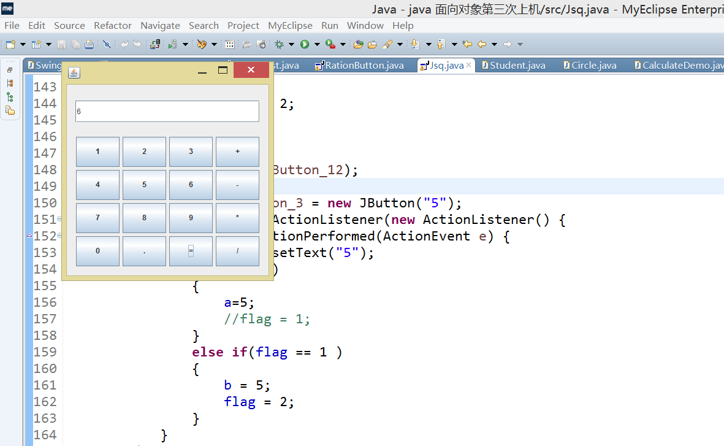

- 课本P192 第10题。必须采用GUI界面类、业务类交互来完成功能！

业务类（学生类）
Student.java;
import java.util.Calendar;

//Circle.java
public class Student_1 {
//attribute
private String name;
private int year;
private int month;
private int day;

//method
public Student_1(String name,int year,int month,int day){
setDay(day);
setMonth(month);
setName(name);
setYear(year);
}

public String getName() {
return name;
}

public void setName(String name) {
this.name = name;
}

public int getYear() {
return year;
}

public void setYear(int year) {
this.year = year;
}

public int getMonth() {
return month;
}

public void setMonth(int month) {
this.month = month;
}

public int getDay() {
return day;
}

public void setDay(int day) {
this.day = day;
}
public int calAge(){
Calendar c1 = Calendar.getInstance();
int year = c1.get(Calendar.YEAR);
int month = c1.get(Calendar.MONTH);
if(this.month>month)
{
return (year-this.year-1);
}
else
{
return (year-this.year);
}
}

}
界面类：
import java.awt.Container;
import java.awt.FlowLayout;
import java.awt.event.ActionEvent;
import java.awt.event.ActionListener;
import java.text.DecimalFormat;
import java.text.ParseException;
import java.text.SimpleDateFormat;
import java.util.Date;

import javax.swing.JButton;
import javax.swing.JFrame;
import javax.swing.JLabel;
import javax.swing.JOptionPane;
import javax.swing.JPanel;
import javax.swing.JTextArea;
import javax.swing.JTextField;

//CalculateDemo

public class Student extends JFrame implements ActionListener {
Student_1 stu;
JTextField messageTextName,messageTextYear,messageTextDay,messageTextMonth;
JTextArea resultText;
JButton calBtn;
JButton closeBth;

//Constructor
public Student(){
super("计算圆的面积和周长");

/*创建容器*/
Container c = this.getContentPane();
c.setLayout(new FlowLayout());
JPanel centerPanel = new JPanel(new FlowLayout());
JPanel centerPane2 = new JPanel(new FlowLayout());
JPanel centerPane3 = new JPanel(new FlowLayout());

//创建组件标签，文本款和按钮
messageTextName = new JTextField(10);
messageTextYear = new JTextField(4);
messageTextDay = new JTextField(2);
messageTextMonth = new JTextField(2);
JLabel messageJLabel = new JLabel(" 请 输 入 姓 名 ");
JLabel messageJLabel1 = new JLabel("请输入出生日期");
calBtn = new JButton("计算年龄");
closeBth = new JButton("关闭窗口");
resultText = new JTextArea("计算结果:",4,20);

//添加组件到容器
centerPanel.add(messageJLabel); //请输入姓名
centerPanel.add(messageTextName);
centerPane2.add(messageJLabel1); //请输入出生日期
centerPane2.add(messageTextYear);
centerPane2.add(messageTextMonth);
centerPane2.add(messageTextDay);
centerPane3.add(calBtn);
centerPane3.add(closeBth);
c.add(centerPanel);
c.add(centerPane2);
c.add(centerPane3);
c.add(resultText);

//注册事件到监听器
calBtn.addActionListener(this);
closeBth.addActionListener(this);

this.setDefaultCloseOperation(JFrame.EXIT_ON_CLOSE);
this.setSize(300,270);
this.setVisible(true);
}

public static void main(String args[]){
new Student();
}

public void actionPerformed(ActionEvent e) {
//判断事件源是否是"计算"按钮
if(e.getSource() == calBtn){
calculate();
}
if(e.getSource() == closeBth){
shutDown();
}

}

//处理按钮"计算"事件方法
private void calculate(){
String messagename = messageTextName.getText();
String messageYear = messageTextYear.getText();
String messageMonth = messageTextMonth.getText();
String messageDay = messageTextDay.getText();
int Year = Integer.parseInt(messageYear);
int Month= Integer.parseInt(messageMonth);
int Day = Integer.parseInt(messageDay);

if(messageYear.length() == 0)
JOptionPane.showMessageDialog(null,"请输入学生信息!","提示",1);
else{

Student_1 Stud = new Student_1(messagename, Year,Month, Day);

int age = Stud.calAge();

//在文本区域中显示计算的结果，小数点后保留两位
resultText.setText("计算结果如下:\n");
resultText.append(messagename+"的年龄"+ age);
}
}

public void shutDown(){
System.exit(0);
}

}
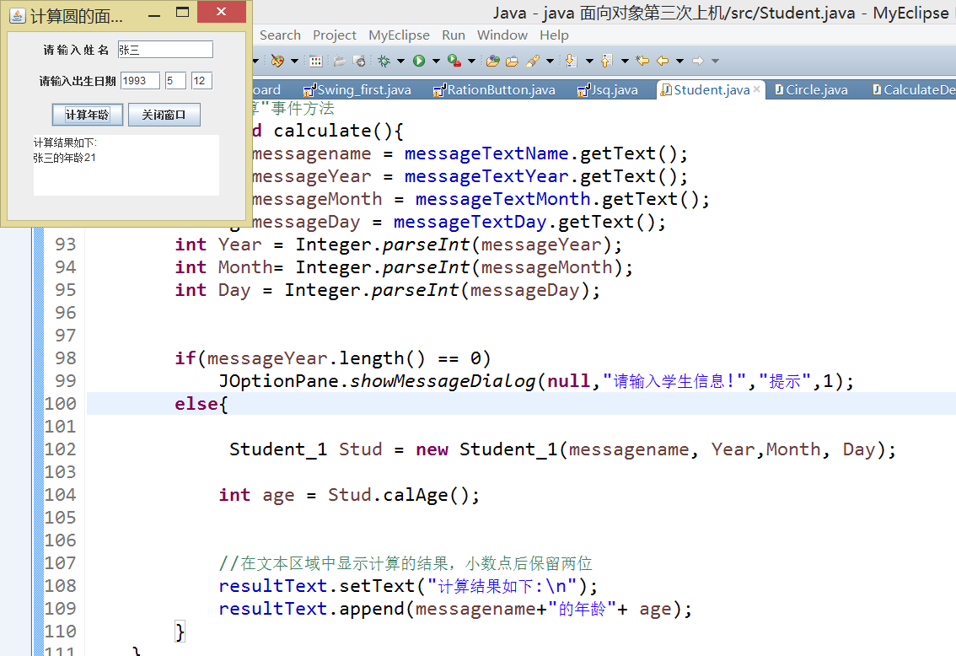”” ;

以上4题必须是全部自己写代码来实现界面、功能。
- 试试使用Swing插件Matisse Form来完成以上第3题，并仔细体会两种实现有何不同。提示：创建项目时，选择 新建 -> Other -> MyEclipse ->Swing ->Matisse Form （以上是针对MyEclipse的）
若本机安装的是Eclipse，请安装WindowBuilder插件后也可实现以上第3题功能（如何安装插件也要贴图）。

